

FURTHER MATHEMATICS
TRIAL EXAMINATION 1
2010
SOLUTIONS

SECTION A - answers SECTION B - answers

Core Module 1 Module 2 Module 3 Module 4 Module 5 Module 6
Number Geometry Graphs Business Networks Matrices
patterns & & related &
trig relations maths decision

maths
1. A 1. B 1. B 1. D 1. A 1. B 1. A
2. E 2. D 2. C 2. D 2. C 2. D 2. E
3. C 3. B 3. B 3. B 3. B 3. A 3. D
4. B 4. C 4. C 4. B 4. A 4. B 4. D
5. B 5. E 5. E 5. C 5. E 5. C 5. E
6. D 6. A 6. A 6. E 6. D 6. B 6. C
7. D 7. E 7. E 7. A 7. E 7. E 7. E
8. B 8. D 8. C 8. D 8. D 8. C 8. B
9. D 9. C 9. D 9. C 9. B 9. B 9. C
10. D
11. E
12. A
13. C

SECTION A - solutions

CORE: Data analysis

Question 1

The mode is the most frequently occurring or most popular score.
The mode is 0.
The answer is A.

Question 2

Method 1 – using a calculator
Enter the scores 0,0,0,0,0…4,5,7 and calculate the 1- variable stats.
Mean = 2
The answer is E.

Method 2 – by hand
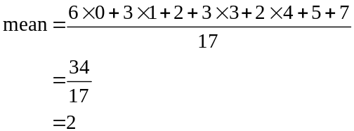
The answer is E.
Question 3

0 | 4
0 | 5 | 7 | 8 | 9
1 | 0 | 2 | 3 | 3 | 4
1 | 6 | 8 | 9
2
2 | 7

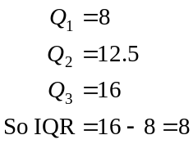
The answer is C.

Question 4

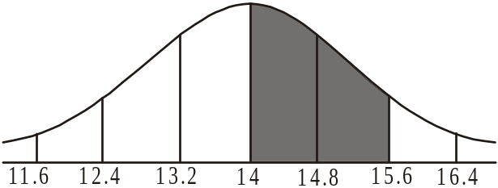

Because of the symmetry of the normal distribution we know that we have 95% of the population within 2 standard deviations either side of the mean.
The shaded area above represents 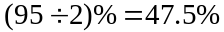.
The answer is B.

Question 5

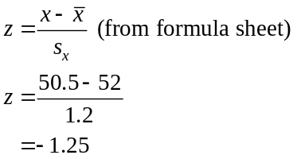

The answer is B.

Question 6

Looking at the middle column, which represents Year 9 students, the middle segment representing texts is .
The answer is D.
Question 7

Using a calculator, calculate r.
The answer is 0.9207… so the closest option is 0.9207.
The answer is D.

Question 8

For the man with an original body weight of 115kg, the equation predicts his loss to be
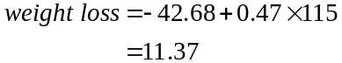
His actual weight loss was 9kg.
residual value = actual value – predicted value (from formula sheet)
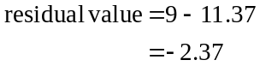
The answer is B.

Question 9

The variable size is categorical.
The variable number ordered is a numerical variable.
A bar chart is the most suitable way of displaying the relationship.
The answer is D.

Question 10

In order to linearise the data, the plot should be 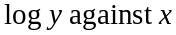.
(you could also try against x or y against 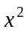 but these options are not on offer).
In this context the plot should be 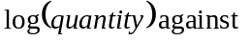cost.
The answer is D.

Question 11

Enter the data for the variables month number and cost. Note that month number is the independent variable and cost is the dependent variable. The least squares regression line equation is
cost.
The answer is E.

Question 12

2-moving 2-moving
mean mean
with
centring
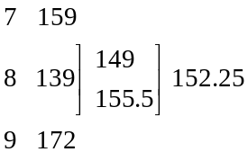
The answer is A.

Question 13

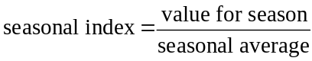
In this question a season is a month.

Seasonal average
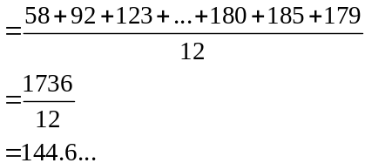
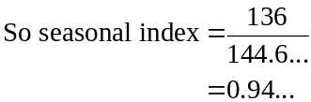
The closest answer is 0.94.
The answer is C.

SECTION B

Module 1: Number patterns

Question 1

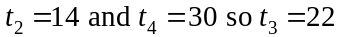
The common difference is 8 so 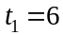.
The answer is B.

Question 2

For the geometric sequence 20, 12, 7.2,…
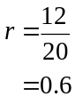
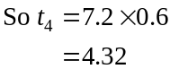
The answer is D.

Question 3

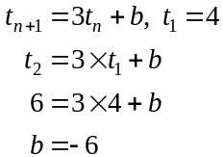
The answer is B.

Question 4

We have an arithmetic sequence with .
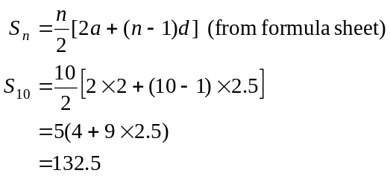
The answer is C.

Question 5

We have an infinite geometric sequence where
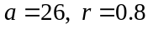
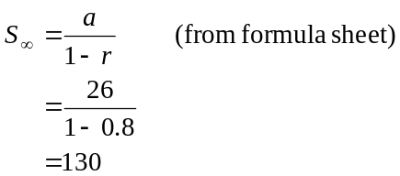
The answer is E.
Question 6

Whilst 94% of material is recycled, 6% remains yet to be recycled so 6% of the material present from the previous day plus the 10 tonnes of newly arrived material is what has to be recycled.
The difference equation is 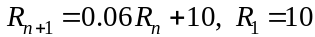
The answer is A.

Question 7

Since the sequence is a Fibonacci related sequence, the ‘next’ term is formed by combining in some way the previous two terms. This eliminates options A and B.
For option C, the sequence generated is 0, 1, 1, 0,…
For option D, the sequence generated is 0, 1, 1, 2,…
For option E, the sequence generated is 0, 1, 1, 3, 5,… as required.
The answer is E.

Question 8

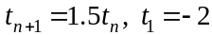
The difference equation generates a geometric sequence given by 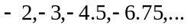
Only option D shows this.
The answer is D.

Question 9

The sequence 2.4, 1.92, 1.536… is a geometric sequence since 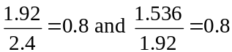
So . We want to find 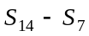.

In the first week the sum of the decreases is given by
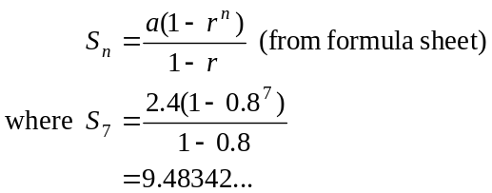

In the first two weeks, the sum of the decreases is given by
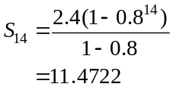

So in the second week after the flood, the height of the river decreases by 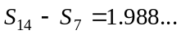.
The closest answer is C.
The answer is C.
Module 2: Geometry and trigonometry

Question 1
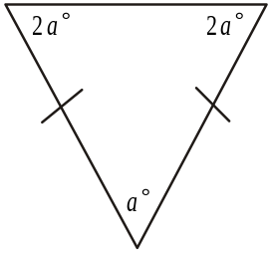
Because the triangle is isosceles it has two sides
of equal length and two angles of equal magnitude.
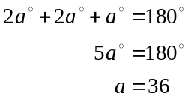
The answer is B.

Question 2

Find .
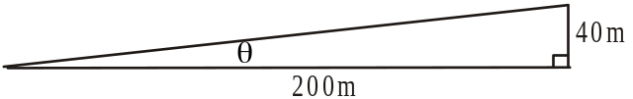
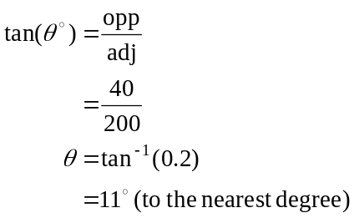
The answer is C.

Question 3

’s VXZ and WXY are similar
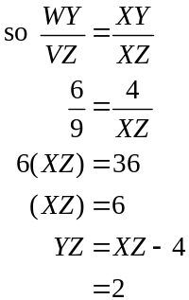
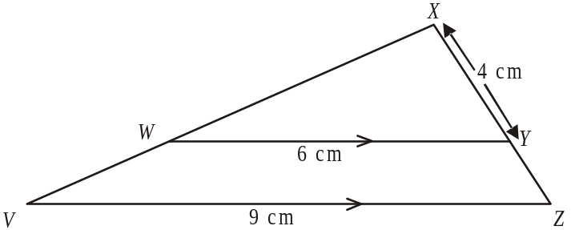
The answer is B.

Question 4

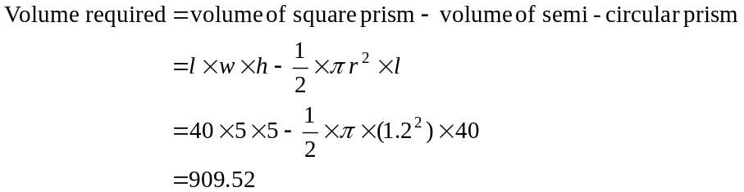
The closest answer is 910cm³.
The answer is C.
Question 5

From point A the land rises to 120m and then falls to 80m before rising again over a very short distance to 90m. Only option E offers this possibility.
The answer is E.

Question 6
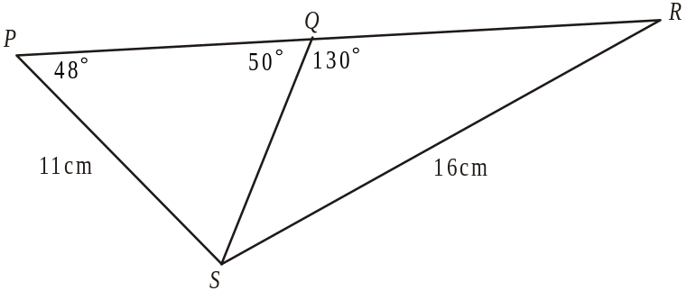

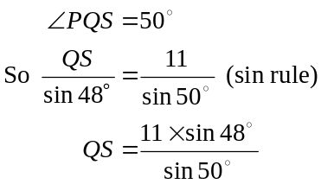
The answer is A.

Question 7
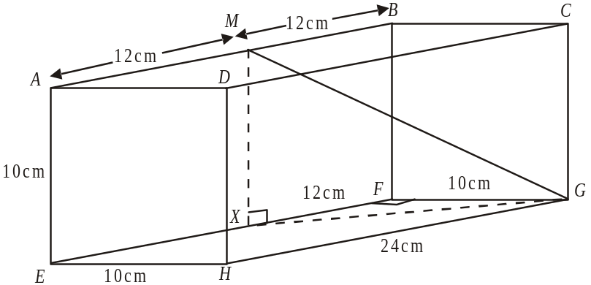

In ,
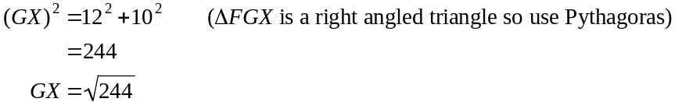
In 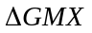
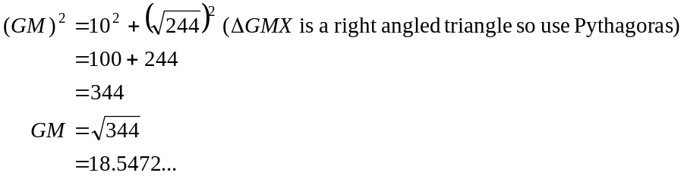
The closest answer is 18.5cm.
The answer is E.
Question 8

Since the octagon is regular,
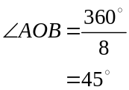
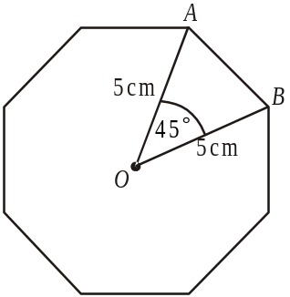
Also 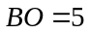cm
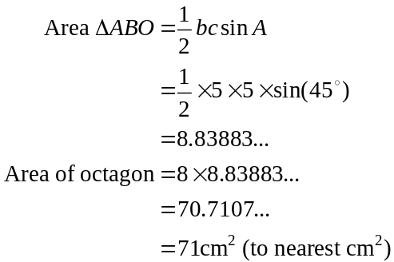
The answer is C.

Question 9
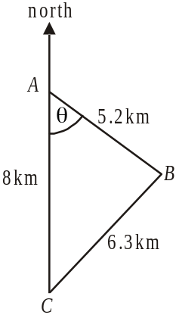
Use the cosine rule to find .
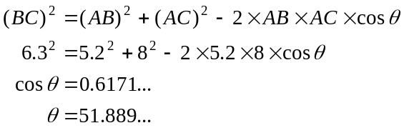
So the required bearing is 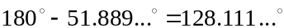
The bearing is closest to 128°.
The answer is D.

Module 3: Graphs and relations

Question 1

The temperature was in the 1° C– 4° C range between 0 – 5 hours, 10 – 12 hours, 13 – 15 hours, 17 – 20 hours and 22 – 24 hours.
The food could be safely stored for .
The answer is D.

Question 2

The monthly membership for 18 classes is $20.
The monthly membership for 50 classes is $40.
Joan pays $60 per month.
The answer is D.

Question 3

The rule that describes the graph is

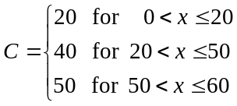
The answer is B.

Question 4

Let x be the cost of 1kg of bananas.
Let y be the cost of 1 punnet of strawberries.

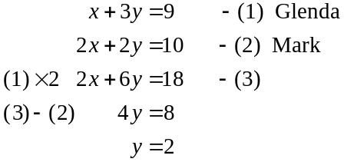
One punnet of strawberries costs $2.
The answer is B.

Question 5

Let
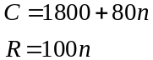
At break even, .
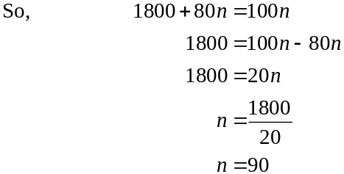
The answer is C.
Question 6

Both lines must pass through the point 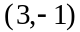; that is, the point must satisfy the equation of both lines. Substitute the values 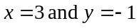 into each equation.
For option A, 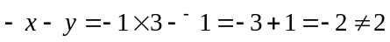.
For option B, 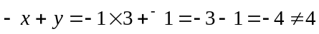.
For option C, 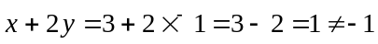.
For option D, 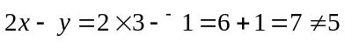.
For option E, 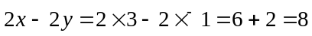.
The point 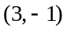 only satisfies the equation 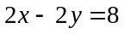 so only the line with equation 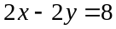 passes through this point.
The answer is E.

Question 7

The constraints are
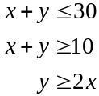
Only option A shows these constraints.
The answer is A.

Question 8

For the graph shown, the relationship between y and x² is 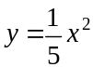.
For 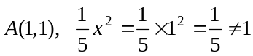.
For 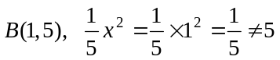.
For 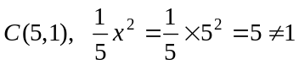.
For 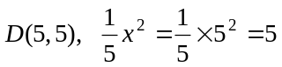.
The answer is D.

Question 9

Profit = Revenue – Costs
On 400 lipsticks,
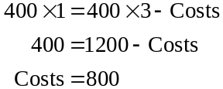
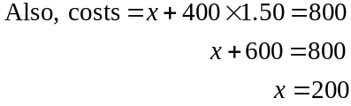
The answer is C.
Module 4: Business-related mathematics

Question 1

Jarrod’s minimum monthly balance for April was $522.31.
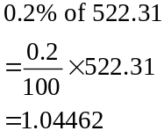
The interest payment is $1.04.
The answer is A.

Question 2

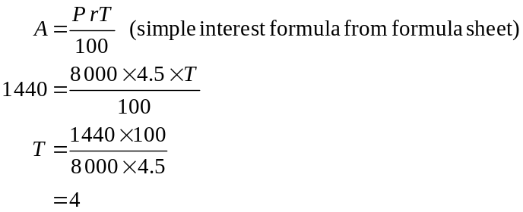
The answer is C.

Question 3

To find the GST included in the price of something divide by 11.
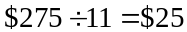.
The answer is B.

Question 4
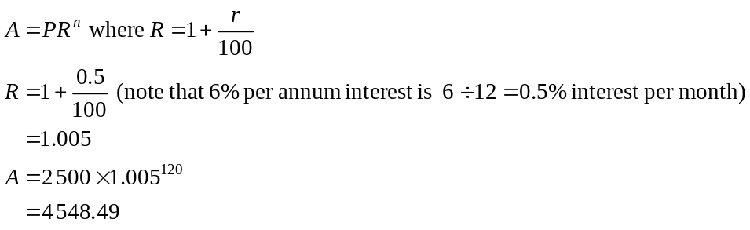
The answer is A.

Question 5

Method 1
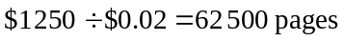
The answer is E.

Method 2
For every $1 the shredder is depreciated, it will need to have shredded 50 pages because 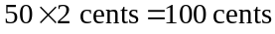.
So for $1250, it will have needed to shred 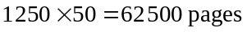.
The answer is E.
Question 6

Let x be Angela’s premium 2 years ago.
After 1 year Angela’s premium increased to .
After the second year, Angela’s premium increased to 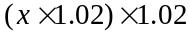.
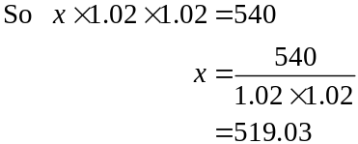
The answer is D.

Question 7
Brad pays a total of 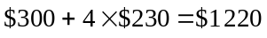.
So he pays 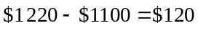 in interest.
This represents a flat rate of 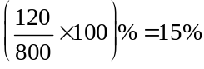.
This represents an effective interest rate of approximately 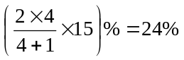(formula sheet)
The answer is E.

Question 8
Use TVM
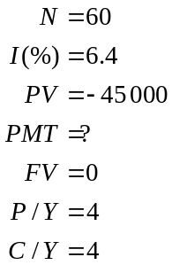

Payment is $1 172.2825… per quarter. Annual payment is 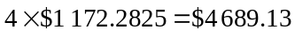.
The answer is D.

Question 9

Use TVM to find Ryan’s quarterly repayments.
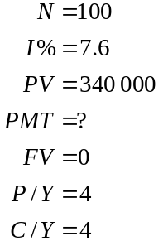
Quarterly payments are $7620.25.
Over the course of the loan he will pay 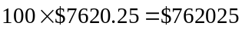.
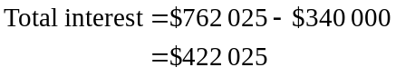
The answer is B.
Module 5: Networks and decision mathematics

Question 1
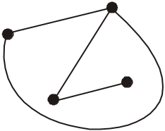
The graph shown to the right is
- connected (there is a path between each pair of vertices)
- planar (no two edges meet except at vertices)
- not simple (because there are multiple edges joining
two of the vertices as shown on the diagram below. In
this case multiple means 2)
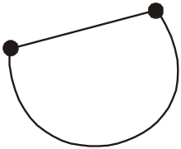

- not complete (because not every pair of vertices is joined by an edge)
Only option B is correct.
The answer is B.

Question 2

The shortest routes are shown.

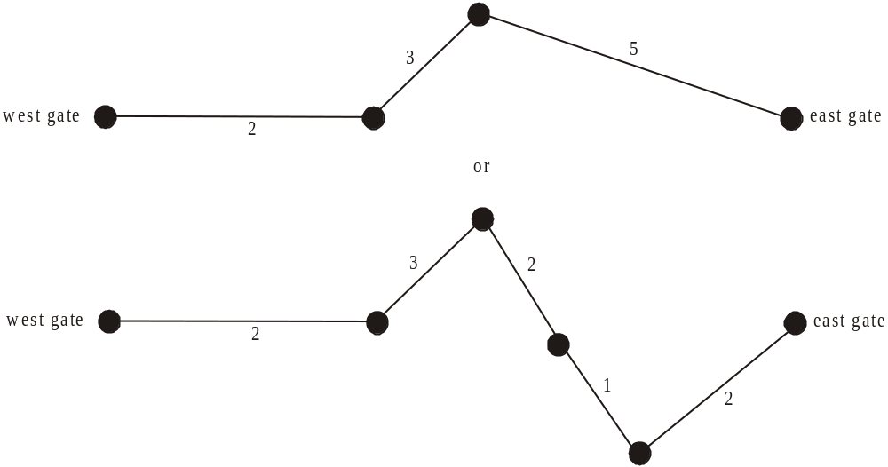

The length of the shortest route is 10km .
The answer is D.

Question 3

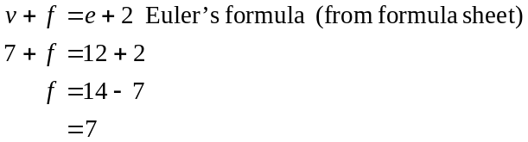
The answer is A.
Question 4

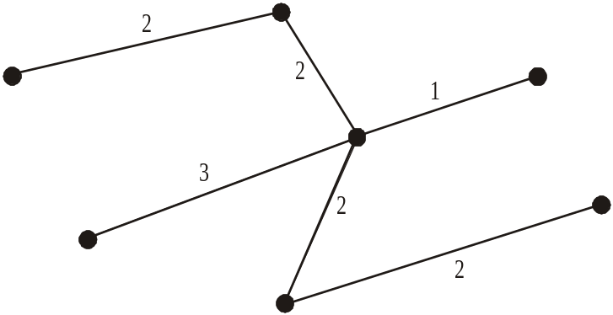

First identify the minimum spanning tree (shown above)
The total weight is .
The answer is B.

Question 5

Method 1 – trial and error

To find the maximum flow, we need first to find the minimum cut.

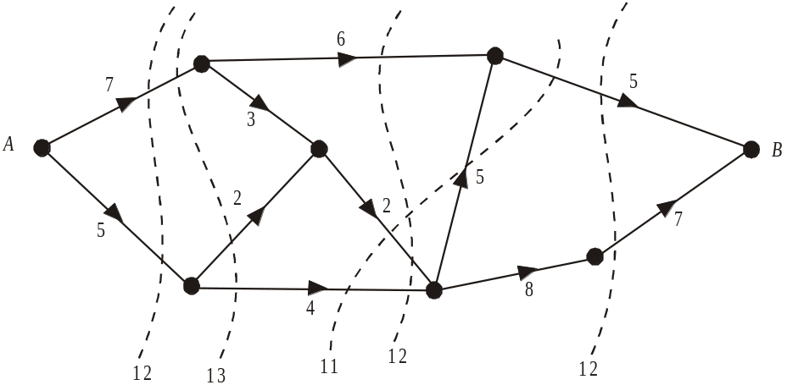

The minimum cut is 11 so the maximum flow possible between A and B is 11.
The answer is C.
Method 2
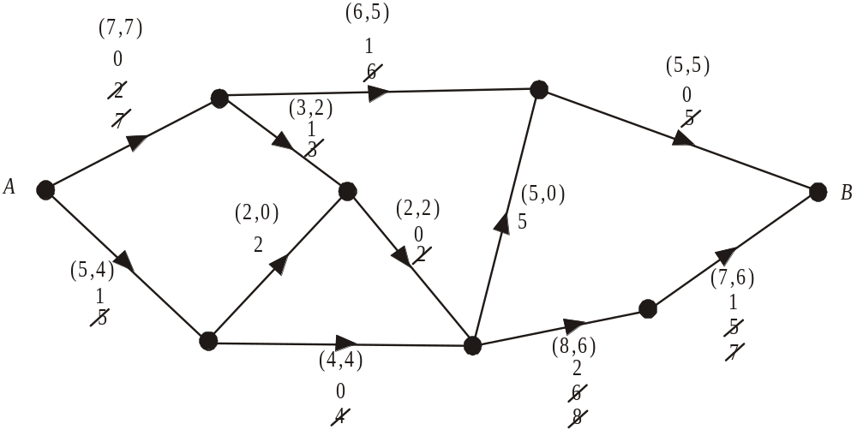

Start with the path along the top of the network.
The smallest capacity is 5. Subtract this from all 3 arcs on the path.
Move to the next path with capacity left i.e. 2,3,2,8,7.
Subtract 2 from each arc.
Move to the next path with capacity left, i.e. 5,4,6,5.
Subtract 4 from each arc.
There are no paths left from A to B with capacity.
Write (initial capacity, final flow) for each arc.
The maximum flow is what flows out of A which is and into B which is .
The answer is C.

Question 6

 | 1 | 2 | 3 | 4
A | 12 | 8 | 8 | 12
B | 11 | 10 | 9 | 10
C | 8 | 12 | 9 | 7
D | 10 | 9 | 11 | 7

Subtract the lowest cost in each row from all other elements in that row.

 | 1 | 2 | 3 | 4
A | 4 | 0 | 0 | 4
B | 2 | 1 | 0 | 1
C | 1 | 5 | 2 | 0
D | 3 | 2 | 4 | 0

Since the first column has no zeroes, subtract the least cost from the first column.

 | 1 | 2 | 3 | 4
A | 3 | 0 | 0 | 4
B | 1 | 1 | 0 | 1
C | 0 | 5 | 2 | 0
D | 2 | 2 | 4 | 0

Draw a bipartite graph with the possible allocations.

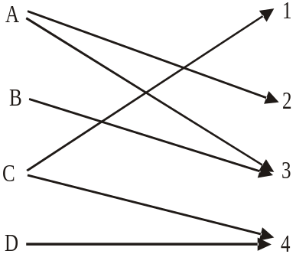

The allocation is A – 2.
B – 3
C – 1
D – 4.
The minimum cost is 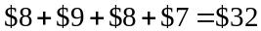.
The answer is B.

Question 7

Euler’s formula only applies to planar graphs; that is, graphs that can be drawn so that the edges only intersect at the vertices.
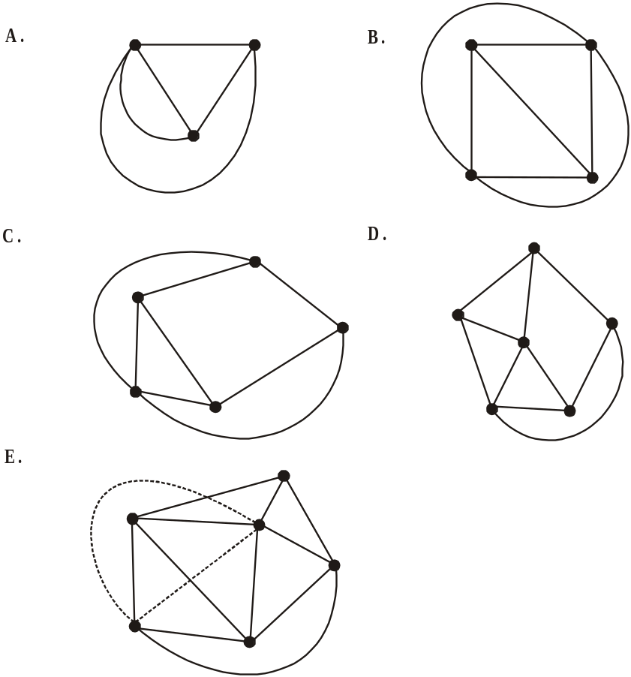

E cannot be redrawn without crossing edges.
The answer is E.

Question 8

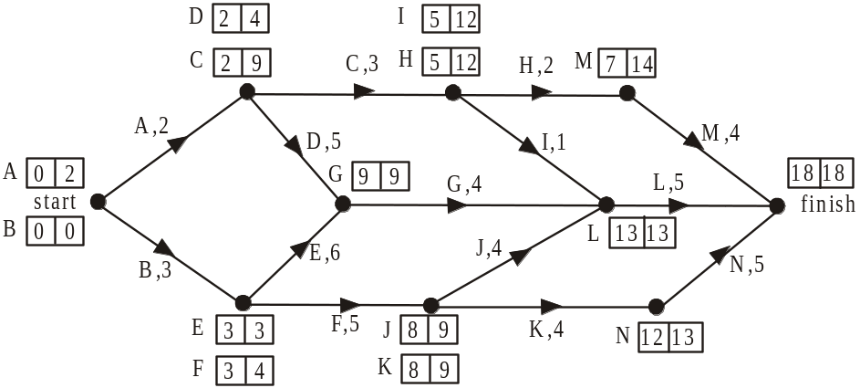

The earliest and latest start times for each activity are shown above.
The critical path is B,E,G,L.
The answer is C.

Question 9

Since activities D and N were not on the original critical path, decreasing them each by 1 day will not cause any activities to become critical. This eliminates options A and E.
Increasing activity F by 1 day will make activities F, J, K and N all critical because activity F is a predecessor to each of the other 3 activities and all four activities have a slack time of 1 week. So option B causes four extra activities to become critical.
Option C only makes two additional activities critical; ie F and J.
Option D only makes three additional activities critical ie F, K and N.
The answer is B.
Module 6: Matrices

Question 1

The element 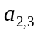 is the element in the second row and the third column. That element is 1.
The answer is A.

Question 2

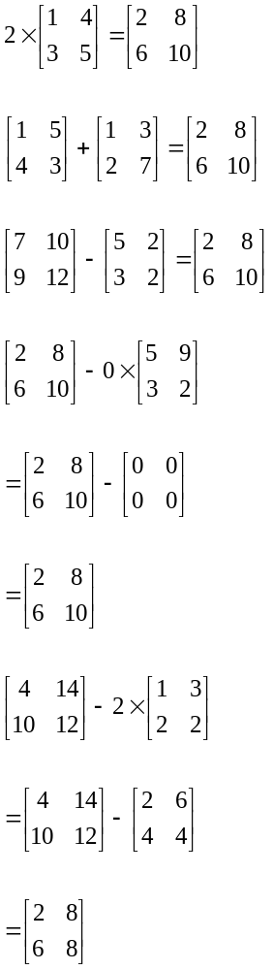
The answer is E.

Question 3

The only matrices are C and D.
Option D gives the Year 2 reading levels.
The answer is D.

Question 4

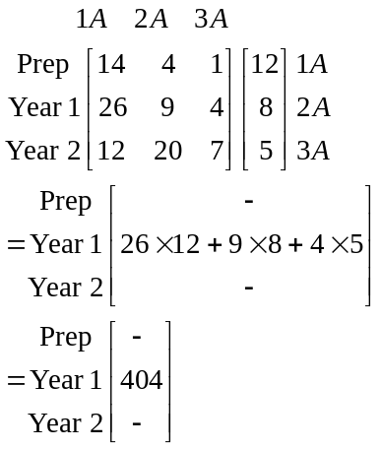
The answer is D.

Question 5
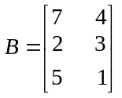, so matrix B is a 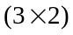 matrix. Also, matrix X is a square matrix.
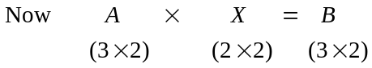
The number of rows of A gives the number of rows of B. So A has 3 rows.
The number of columns of X gives the number of columns of B so X has 2 columns.
Because X is a square matrix it must have 2 rows.
For the product AX to be defined, the number of columns of A must equal the number of rows of X.
The answer is E.

Question 6
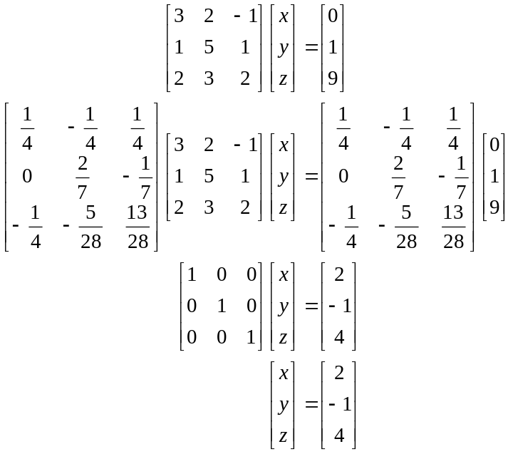
(Note: the working above is shown just to illustrate the process and to show the inverse matrix. You don’t need to do all this – rather, just keep the calculations in your calculator.)
The answer is C.
Question 7

The columns of a transition matrix should add to give one.
We can eliminate options A and D.
70% watching channel A one night watch channel A the next, but 20% move from channel A to channel B and10% move from channel A to channel C.
80% watching channel B one night watch channel B the next, but 8% move to channel A and 12% move to channel C.
Only options B and E show this.
90% watching channel C one night watch channel C the next, but 5% move to channel A and 5% move to channel B. Only option E shows this.
The answer is E.

Question 8

The information given can be recorded as shown.

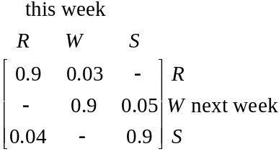

Since the columns of a transition matrix add to give 1, we can calculate the remaining entries.

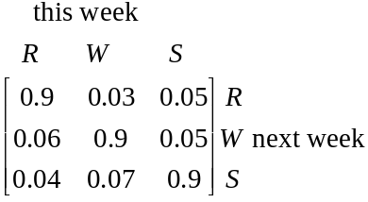
The answer is B.

Question 9

The state matrix for 2009 is 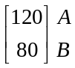
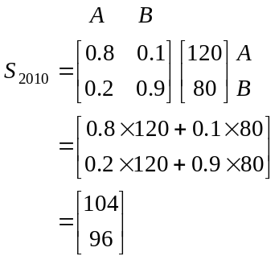
There are 96 campers expected to be camping at site B in 2010.
The answer is C.

